GRADE 7 ACCELERATED · UNIT 2
Unit 2 Review
Real Numbers, Square Roots and Cube Roots ANSWER KEY

HOW TO USE THIS. This review covers every learning target from all six lessons of Unit 2 — more than the assessment does. Work it in parts. If you miss two or more in a part, that part is where to spend your study time. The reference sheet has everything you need for each part.
PART A. Square Values and Square Roots
Lessons 1 and 2 · MA.8.AR.2.3 · 9 questions
1. List every perfect square from 1 to 225.
These are 1² through 15². Write them out once and the rest of this unit gets easier.
Answer. 1, 4, 9, 16, 25, 36, 49, 64, 81, 100, 121, 144, 169, 196, 225

2. Evaluate. 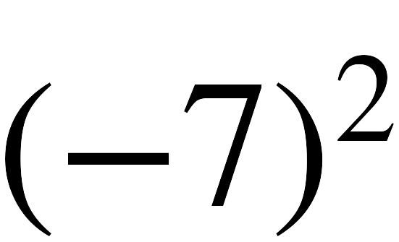
(−7)(−7) = 49. A negative times a negative is positive.
Answer. 49

3. Evaluate. 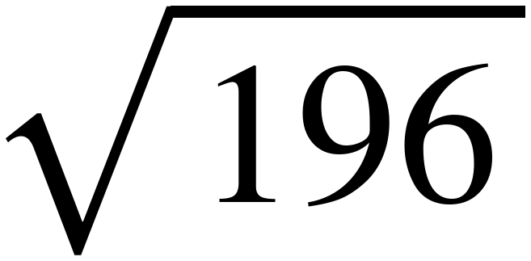
14 × 14 = 196. The radical sign asks for the positive root only.
Answer. 14

4. Evaluate. 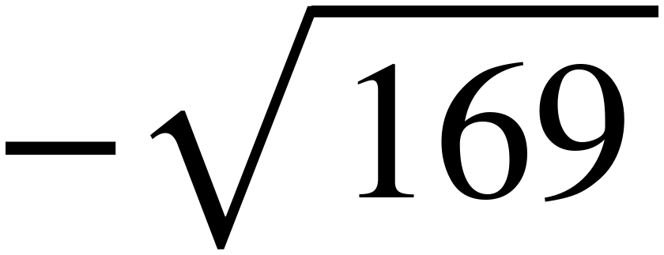
√169 = 13, and the minus sign in front makes it −13. The minus is outside the radical.
Answer. −13

5. Evaluate. 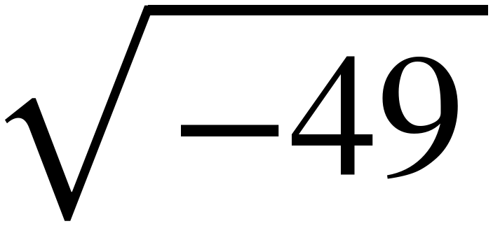
No real number times itself gives −49. Positive × positive is positive and negative × negative is positive.
Answer. Not a real number.

6. A square patio covers 144 square feet. How long is each side?
Side × side = 144, so the side is √144 = 12.
Answer. 12 feet

7. Explain the difference between 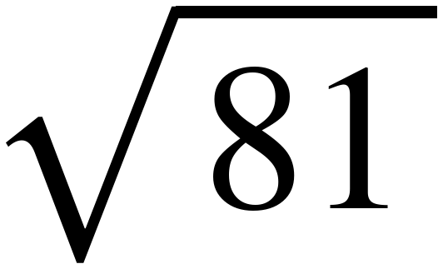 and the solutions of 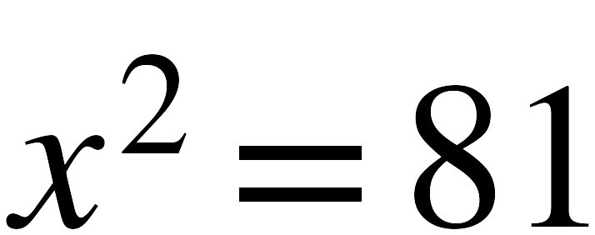 .
The radical sign names one number, the principal square root, and it is never negative.
The equation asks which numbers square to 81, and there are two of them.
Answer. 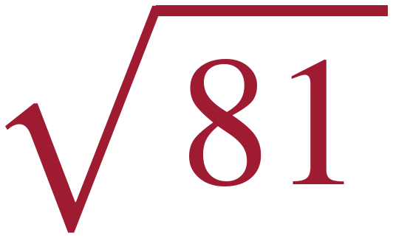 = 9. has two solutions, 9 and −9.

8. True or false: 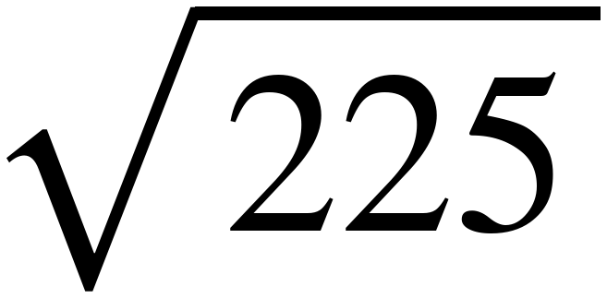 = 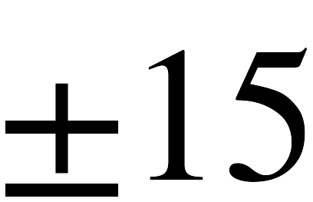
Only x² = 225 has two answers. The radical sign by itself gives 15.
Answer. False. √225 = 15.

9. SSDD. Every part below is about 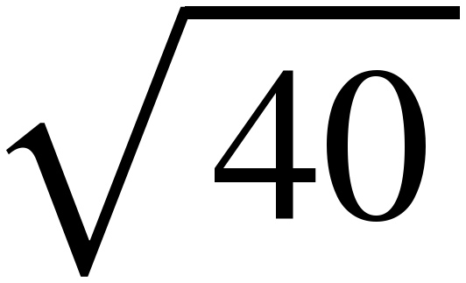 .
Every part is about the same number. They are not the same question — that is the whole item, and it is why the label is on this page and not on theirs.
a. Between which two consecutive integers does lie, and which is it closer to?
36 < 40 < 49, so it lies between √36 = 6 and √49 = 7.
40 − 36 = 4 and 49 − 40 = 9, so 40 sits nearer 36.
Answer. Between 6 and 7, and closer to 6.
b. Is rational or irrational? How do you know?
40 is not a perfect square, so its square root is a decimal that never stops and never repeats.
Answer. Irrational.
c. Solve 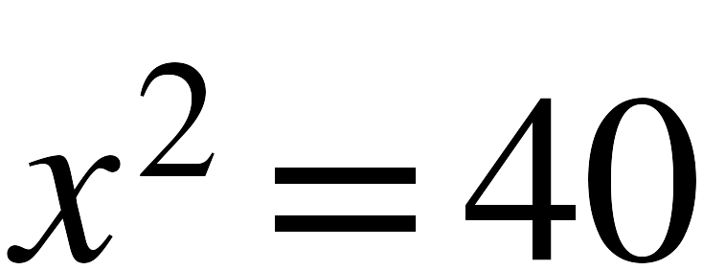 . How many solutions does it have?
The equation asks for every number whose square is 40, and both √40 and −√40 qualify.
This is the one part with two answers. Part a has one number and part b has one word.
Answer. x = ±√40 . Two solutions.
d. ≈ 6.3. Explain why × is exactly 40 but 6.3 × 6.3 is not.
6.3 × 6.3 = 39.69, which is not 40.
√40 is the number that squares to 40 exactly. 6.3 is only the nearest tenth to it.
Answer. Because 6.3 is rounded and the root is exact.
Part a estimates, part b classifies, part c solves and counts solutions, and part d is the exact-versus-rounded distinction. Only part c has two answers, and only part d needs no value for the root at all.

PART B. Cube Values and Cube Roots
Lesson 3 · MA.8.AR.2.3 · 6 questions
10. List every perfect cube from −125 to 125.
These are (−5)³ through 5³. Unlike squares, the list runs through the negatives too.
Answer. −125, −64, −27, −8, −1, 0, 1, 8, 27, 64, 125

11. Evaluate. 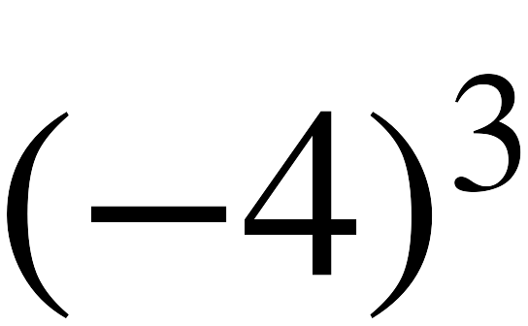
(−4)(−4) = 16, then 16(−4) = −64. Three negative factors leave a negative.
Answer. −64

12. Evaluate. 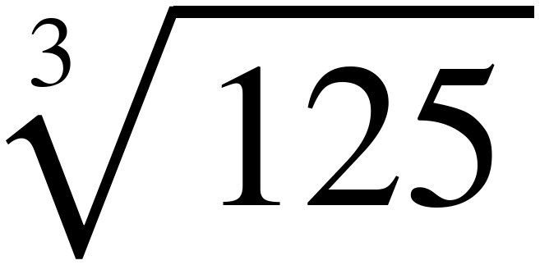
5 × 5 × 5 = 125.
Answer. 5

13. Evaluate. 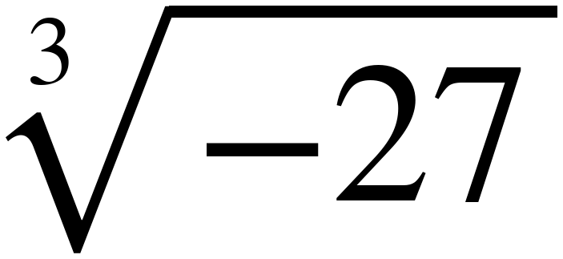
(−3)(−3)(−3) = −27.
Answer. −3

14. A cube holds 64 cubic centimeters. How long is each edge?
Edge × edge × edge = 64, so the edge is ∛64 = 4.
Answer. 4 centimeters

15. Why does 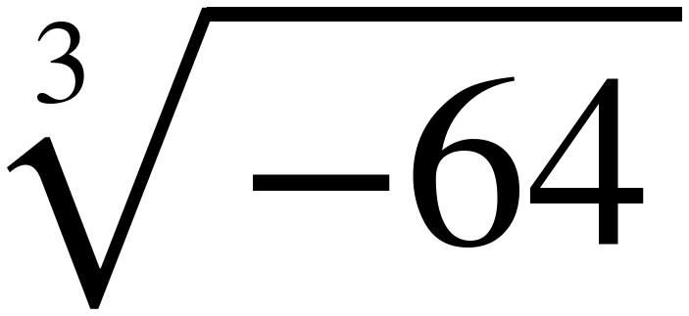 have a real value while 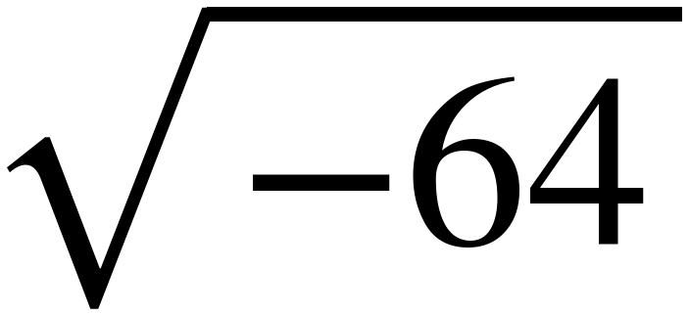 does not?
∛−64 = −4 because (−4)(−4)(−4) = −64.
Nothing squares to a negative: positive × positive and negative × negative are both positive.
Answer. A number multiplied by itself three times can be negative, but a number multiplied by itself twice cannot.

PART C. Solving x² = p and x³ = p
Lessons 2 and 3 · MA.8.AR.2.3 · 6 questions
16. Solve. 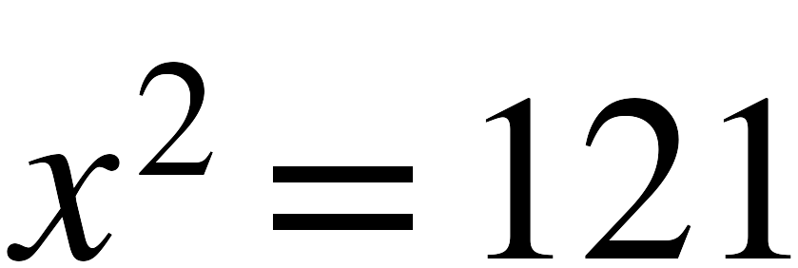
√121 = 11, and −11 squares to 121 as well. Both are solutions.
Answer. x = 11 and x = −11

17. Solve. 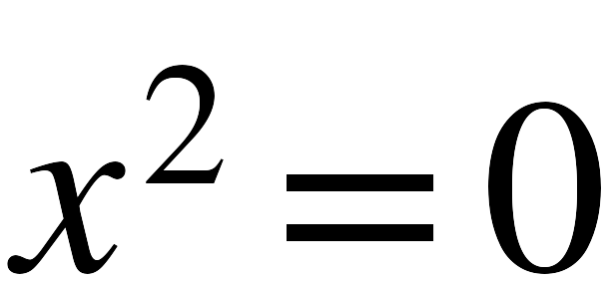
0 × 0 = 0, and no other number squares to 0. This is the one square equation with a single solution.
Answer. x = 0 only

18. Solve. 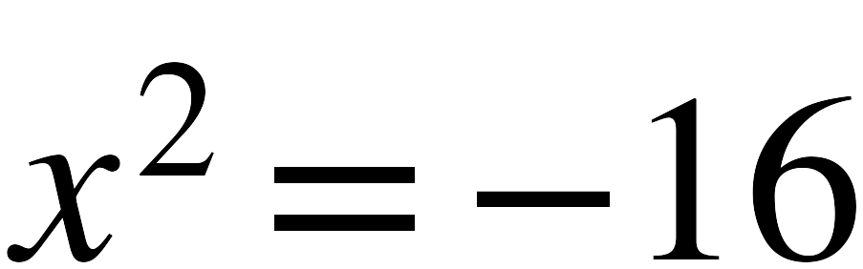
Squaring any real number gives a positive value or zero, never −16.
Answer. No real solutions.

19. Solve. 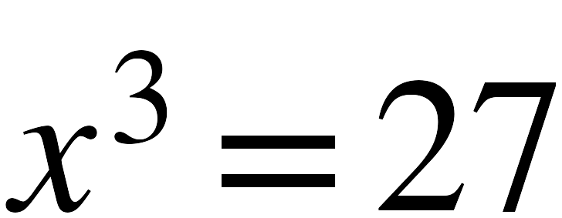
3 × 3 × 3 = 27. Cube equations have exactly one real solution.
Answer. x = 3

20. Solve. 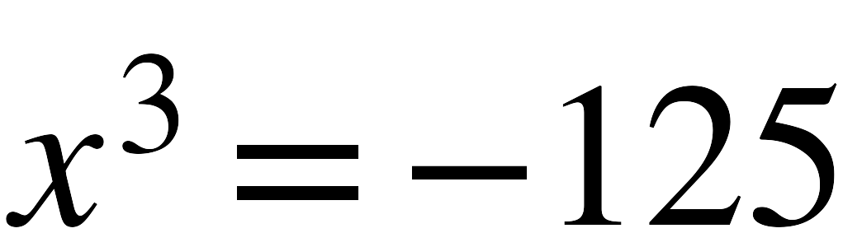
(−5)(−5)(−5) = −125.
Answer. x = −5

21. Select all of the solutions of 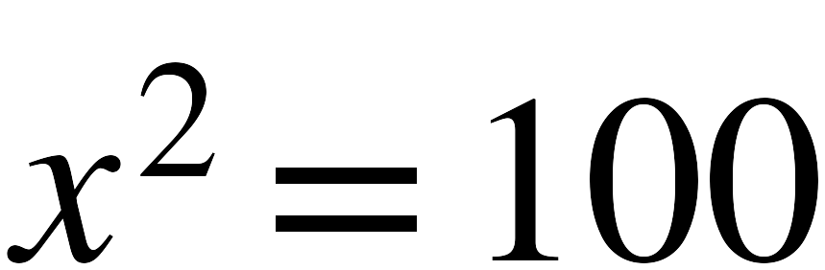 .
☐ | 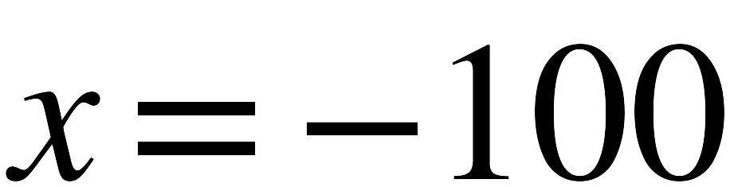 | ☒ | 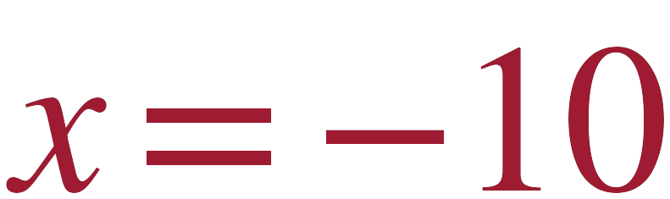 | ☒ | 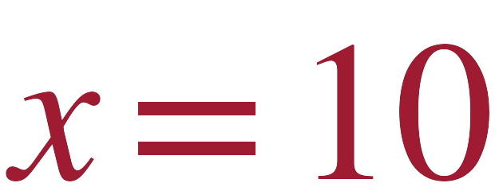
☐ | 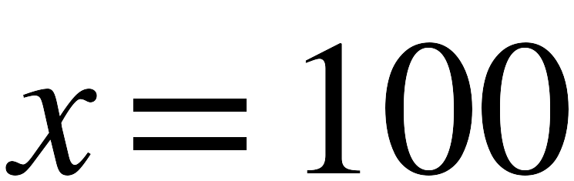
−100 and 100 square to 10 000, not 100. This is the most common wrong pair on this item type.

PART D. Approximating Irrational Numbers
Lesson 4 · MA.8.NSO.1.1 · 6 questions
22. Between which two whole numbers does 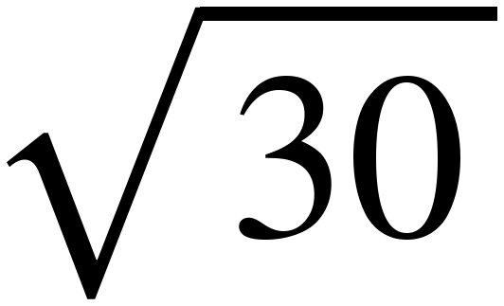 lie? Which is it closer to?
25 < 30 < 36, so √30 is between 5 and 6.
30 − 25 = 5 and 36 − 30 = 6, so 30 sits nearer 25.
Answer. Between 5 and 6, closer to 5.

23. Between which two whole numbers does 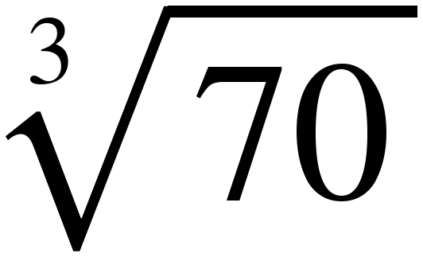 lie? Which is it closer to?
64 < 70 < 125, so ∛70 is between 4 and 5.
70 − 64 = 6 and 125 − 70 = 55, so 70 sits much nearer 64.
Answer. Between 4 and 5, closer to 4.

24. Approximate 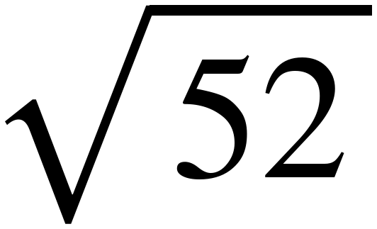 to the nearest tenth.
49 < 52 < 64, so the answer starts with 7.
7.2 × 7.2 = 51.84 and 7.3 × 7.3 = 53.29. 51.84 is closer to 52.
Answer. 7.2

25. Approximate 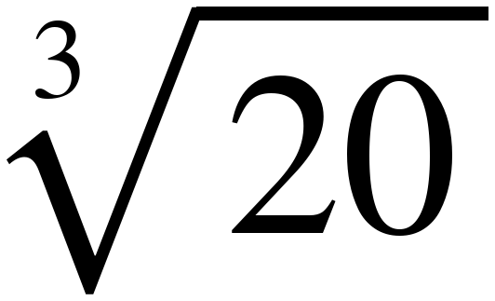 to the nearest tenth.
8 < 20 < 27, so the answer starts with 2.
2.7³ = 19.683 and 2.8³ = 21.952. 19.683 is closer to 20.
Answer. 2.7

26. Approximate 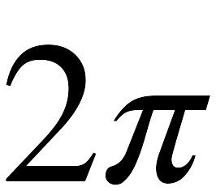 to the nearest tenth.
π ≈ 3.14, so 2π ≈ 6.28, which rounds to 6.3.
Answer. 6.3

27. Dev uses 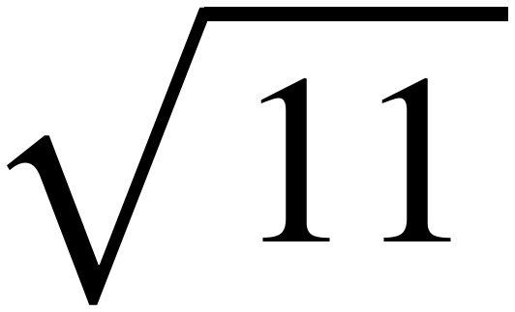 ≈ 3.3 to approximate 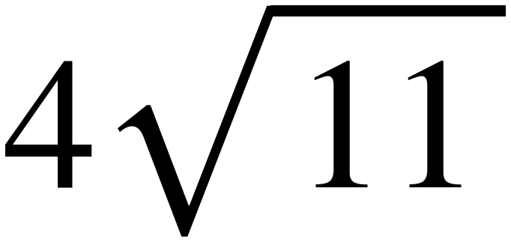 and gets 13.2. A calculator gives 13.3. What went wrong?
√11 = 3.3166…, and 4 × 3.3166 = 13.266, which rounds to 13.3.
Rounding to 3.3 first threw away 0.0166, and multiplying by 4 turned that into 0.066 — enough to change the tenths digit.
Answer. He rounded first. Round last.

PART E. Rational or Irrational
Lessons 4 and 5 · MA.8.NSO.1.1 · 6 questions
28. Is 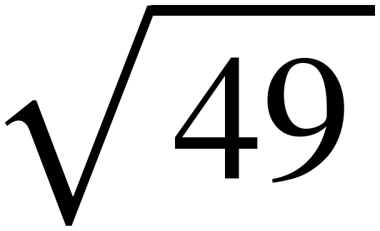 rational or irrational? Explain.
49 is a perfect square, so its root is a whole number, and every whole number is rational.
Answer. Rational. It equals 7.

29. Is 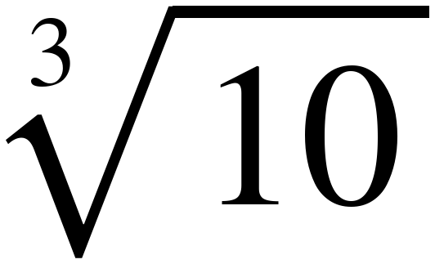 rational or irrational? Explain.
10 is not a perfect cube — it sits between 8 and 27 — so the root never terminates and never repeats.
Answer. Irrational.

30. Is 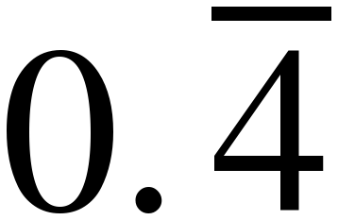 rational or irrational? Explain.
A repeating decimal can always be written as a fraction, and a fraction of whole numbers is rational.
Answer. Rational. It equals  .

31. Is 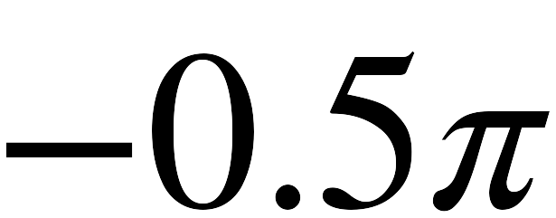 rational or irrational? Explain.
π is irrational, and multiplying an irrational number by a non-zero rational number leaves it irrational.
Answer. Irrational.

32. Is 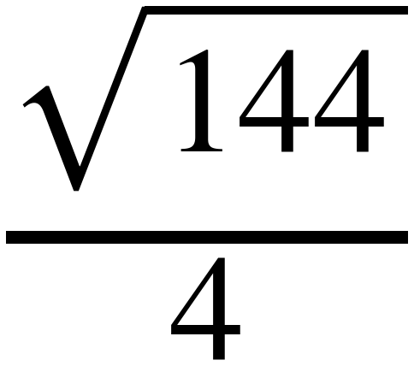 rational or irrational? Explain.
√144 = 12 and 12 ÷ 4 = 3. A radical in an expression does not make the expression irrational.
Answer. Rational. It equals 3.

33. Sort the six numbers into the table.
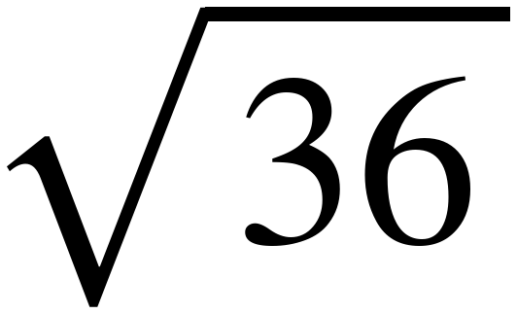 , 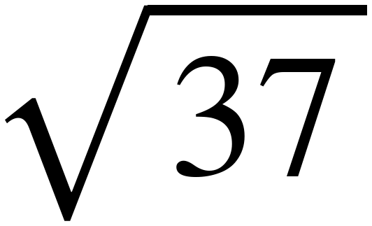 , 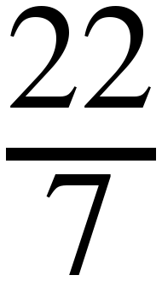 , 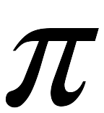 , 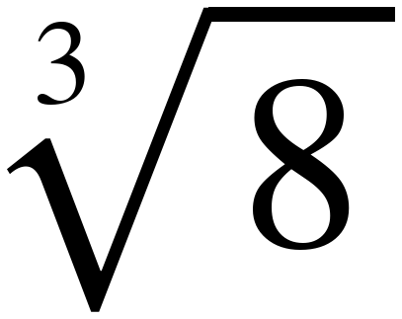 , 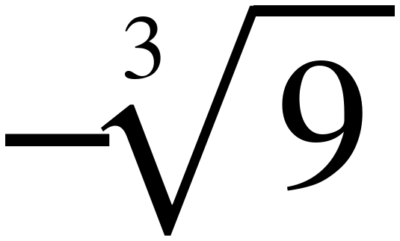
Rational | Irrational
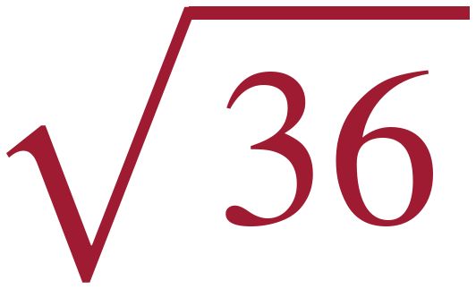    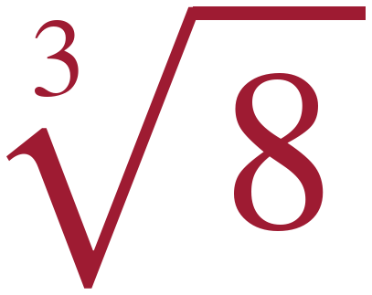 | 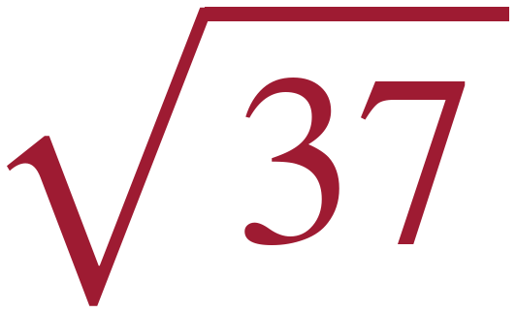    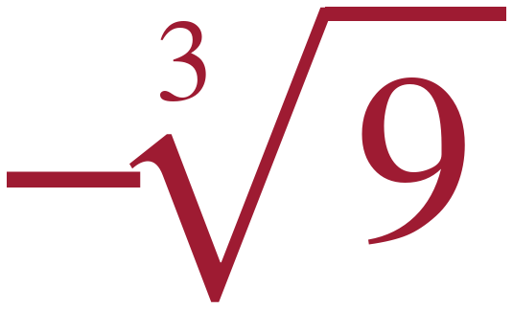
22/7 is the trap. It is a common approximation of π, but it is a fraction of whole numbers, so it is rational. π itself is not.

PART F. Plotting, Ordering and Comparing
Lessons 5 and 6 · MA.8.NSO.1.2 · 8 questions
34. Order from least to greatest. 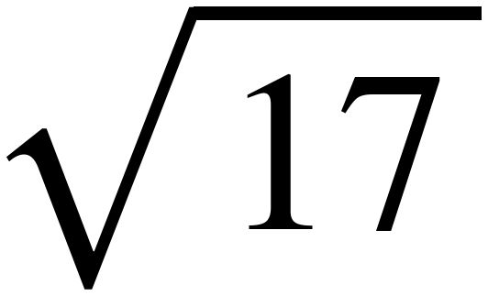 , 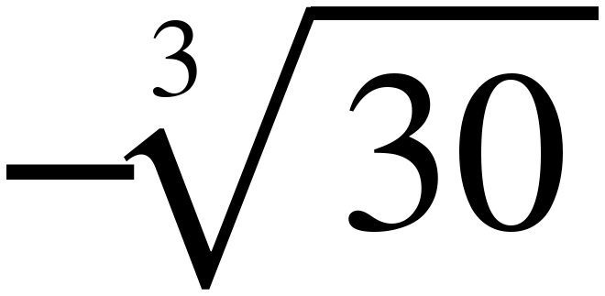 , 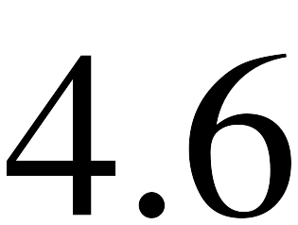 , 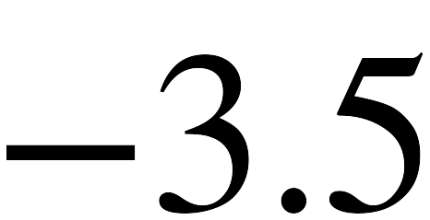 , 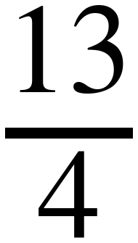
−3.5, −∛30 ≈ −3.1, 13/4 = 3.25, √17 ≈ 4.1, 4.6.
27 < 30 < 64 puts ∛30 between 3 and 4, near 3.1. 16 < 17 < 25 puts √17 just past 4.
Answer. 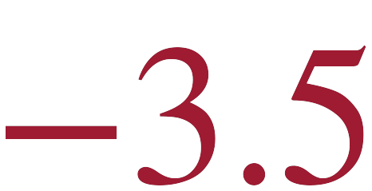 , 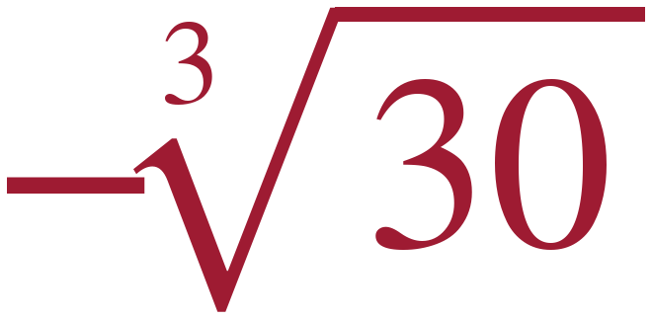 , 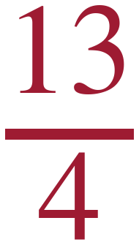 , 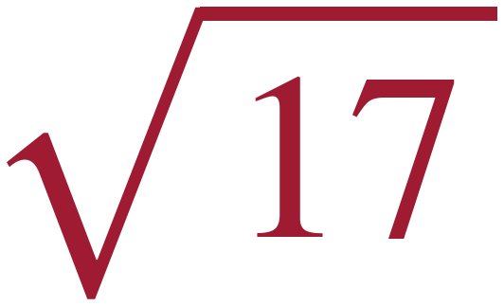 , 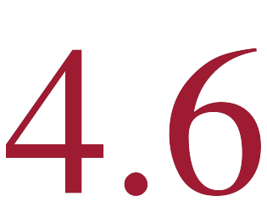

35. Order from least to greatest. 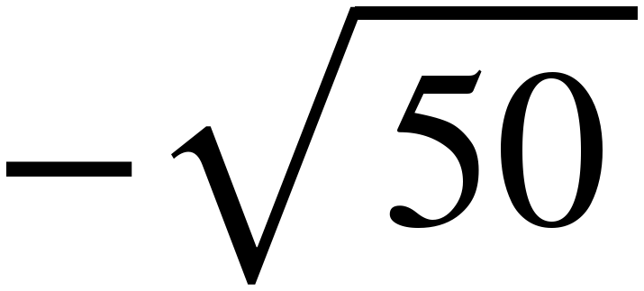 , 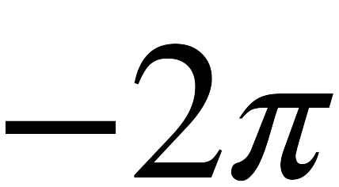 , 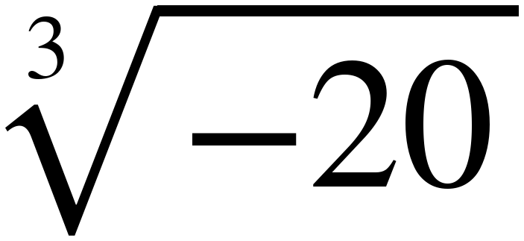 , 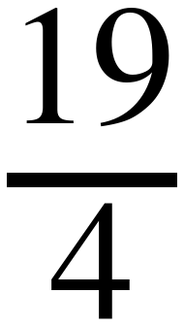 , 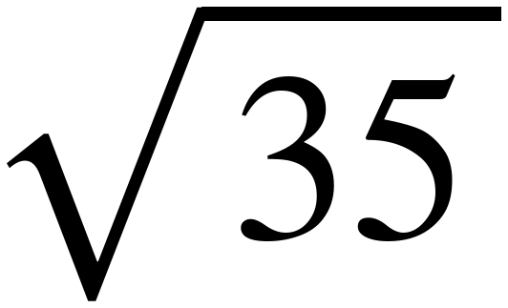
−√50 ≈ −7.1, −2π ≈ −6.3, ∛−20 ≈ −2.7, 19/4 = 4.75, √35 ≈ 5.9.
With negatives, the bigger the root the further left it sits.
Answer. 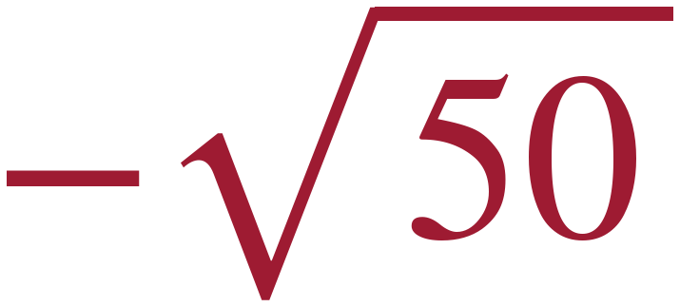 , 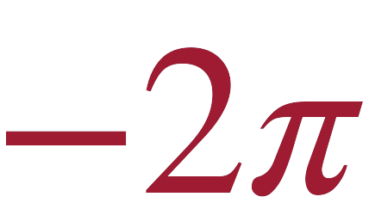 , 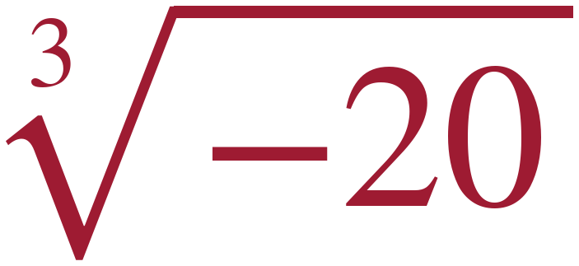 , 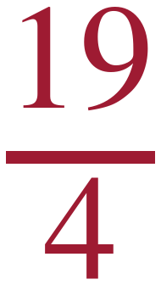 , 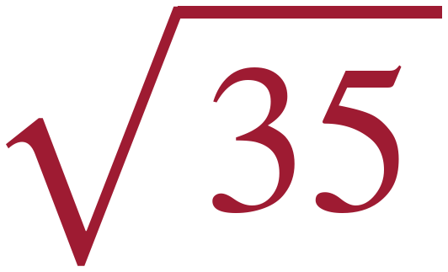

36. Compare using <, > or =. 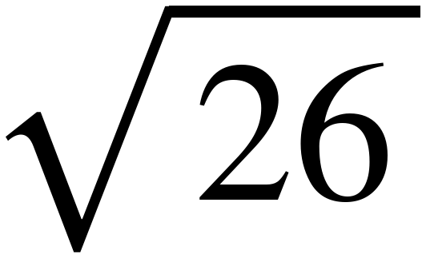 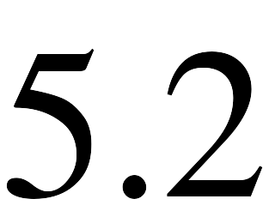
5.2 × 5.2 = 27.04, and 26 < 27.04, so √26 < 5.2. No estimating needed.
Answer. 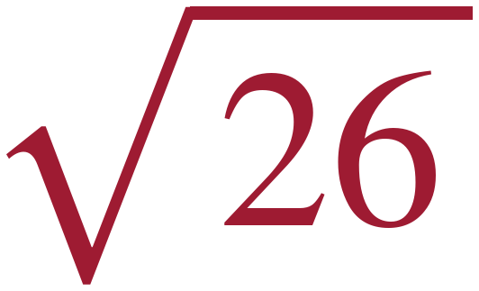 < 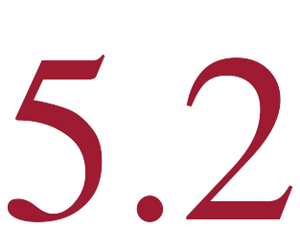

37. Compare using <, > or =. 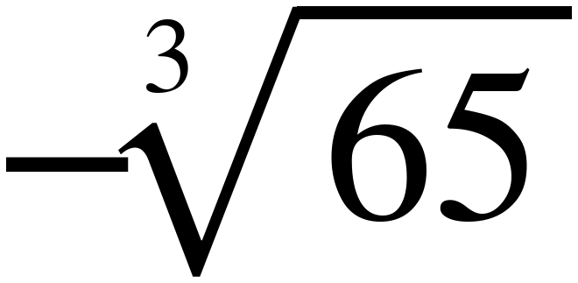 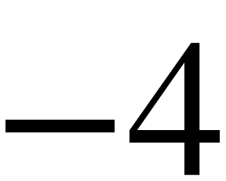
65 > 64, so ∛65 > 4. Putting a minus sign on both flips the comparison: −∛65 < −4.
Answer. 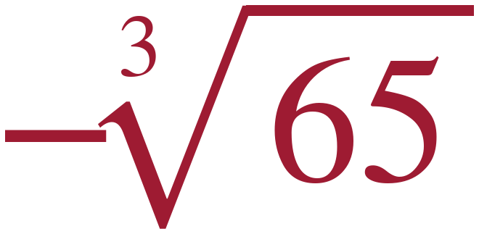 < 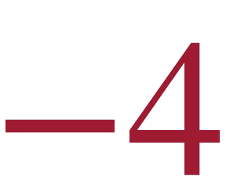

38. Compare using <, > or =. 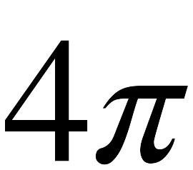 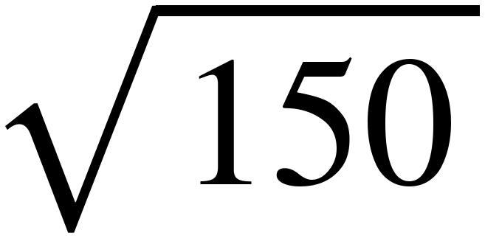
4π ≈ 12.6. 144 < 150 < 169, so √150 is just past 12, about 12.2.
Answer. 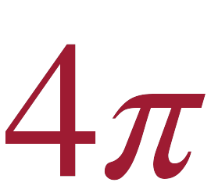 > 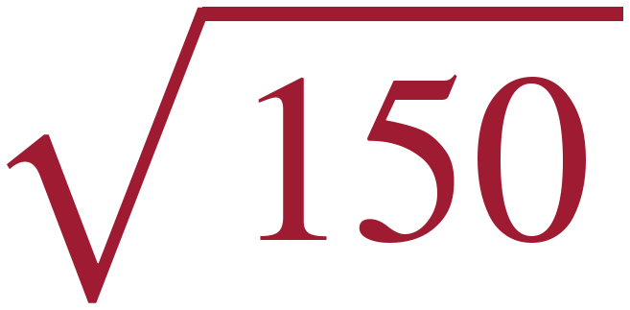

39. Compare using <, > or =. 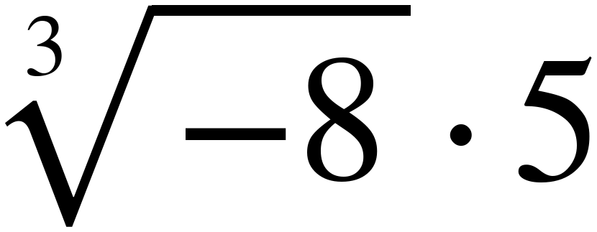 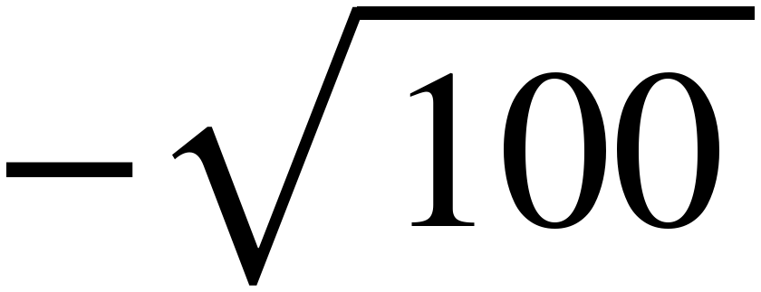
∛−8 = −2 and (−2)(5) = −10. −√100 = −10. They are the same number.
Answer. 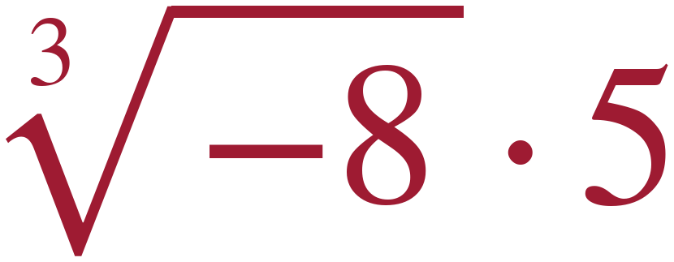 = 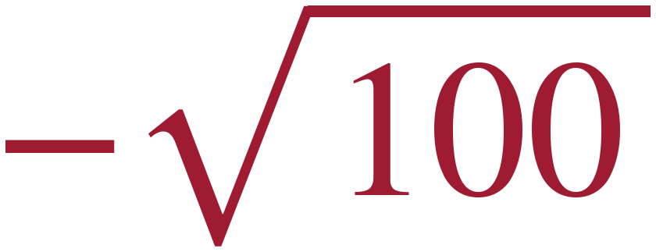

40. Plot and label each value. 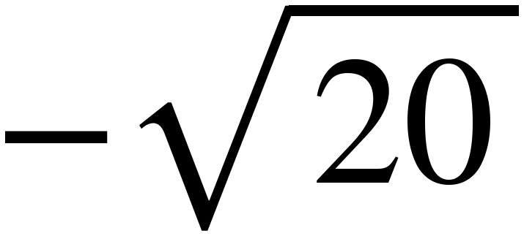 , 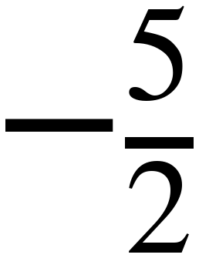 , , 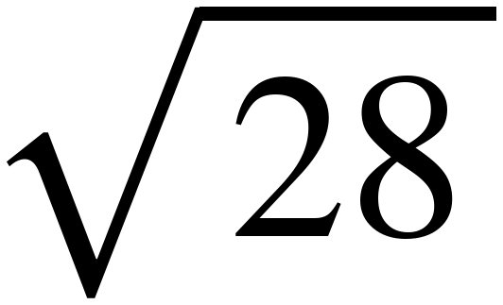
−√20 ≈ −4.5, −5/2 = −2.5, ∛10 ≈ 2.2, √28 ≈ 5.3.
Answer. See the number line.
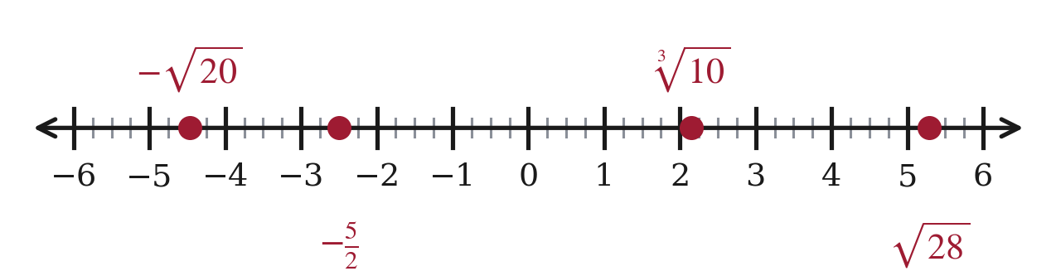

41. Marcus orders , 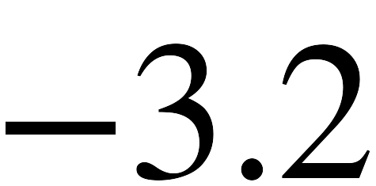 , 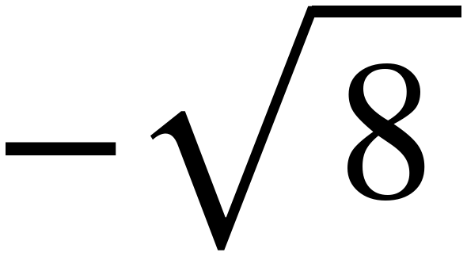 from least to greatest and writes , , . Is he right? If not, fix it.
−∛30 ≈ −3.1, −3.2, −√8 ≈ −2.8.
Marcus wrote the given list BACKWARDS instead of ordering it — reversing a list only helps if it was already in the opposite order, and this one was not. (Ordering by size and dropping the signs would have given −√8, −∛30, −3.2, which is not what he wrote either.) With negatives the number that looks biggest is the smallest: −3.2 has the largest size and sits furthest left.
Answer. No.    